

CREDIT CARD DEFAULT

PREDICATION

Wireframe Documentation



Dnyanesh Yeole

AUGUST 27, 2023

INEURON

# USER INTERFACE

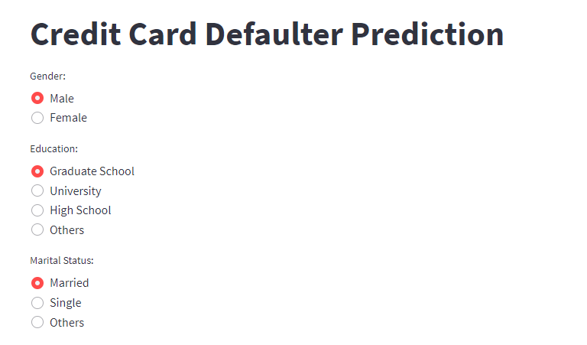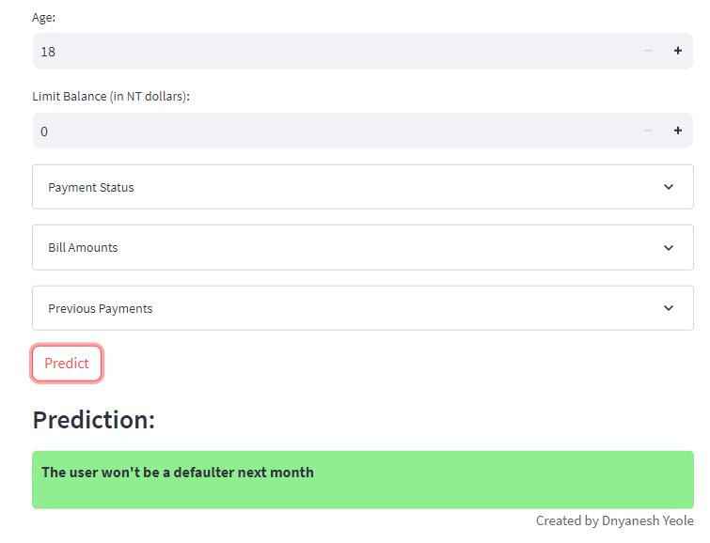

# Section 1: Personal Information

In this section, users provide their personal details for analysis. The features include:

* Gender: Users select their gender from the options provided (Male/Female).
* Education: Users select their education level from the available choices (Graduate School/University/High School/Others).
* Marital Status: Users select their marital status from the options (Married/Single/Others).
* Age: Users input their age using a number slider.
* Limit Balance: Users input their credit limit balance in NT dollars using a number input





# 

# Section 2: Repayment Status

This section gathers information about the user's repayment status for the past six months. The features include:

Repayment Status for Each Month: Users provide their repayment status for each of the past six months. The status is selected from a range of options representing different levels of payment delay.

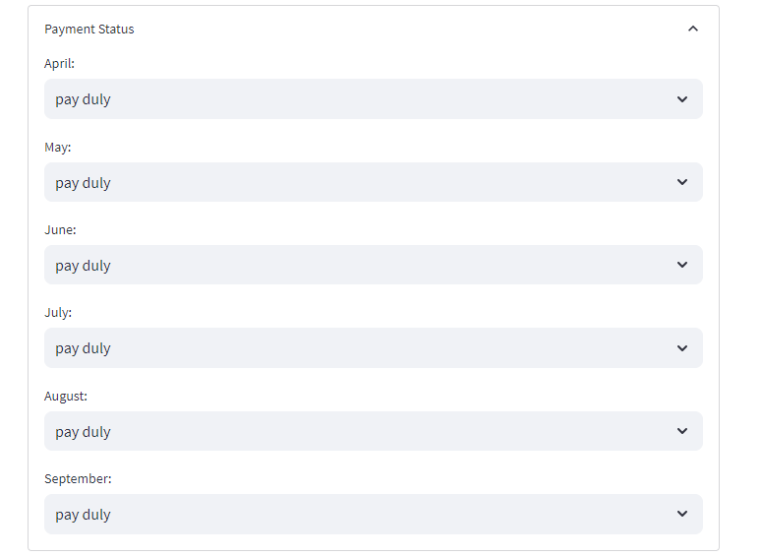

# Section 3: Bill Amounts

In this section, users input their bill amounts for the past six months. The features include:

Bill Amount for Each Month: Users provide their bill amounts for each of the past six months using number inputs.

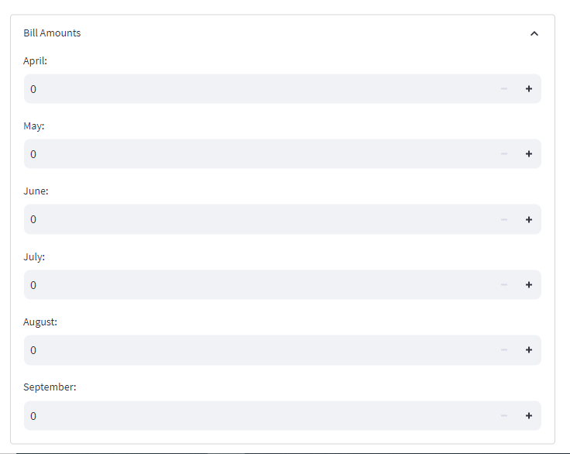

# Section 4: Previous Payments

This section gathers information about the user's previous payments for the past six months. The features include:

Previous Payment Amount for Each Month: Users provide their previous payment amounts for each of the past six months using number inputs

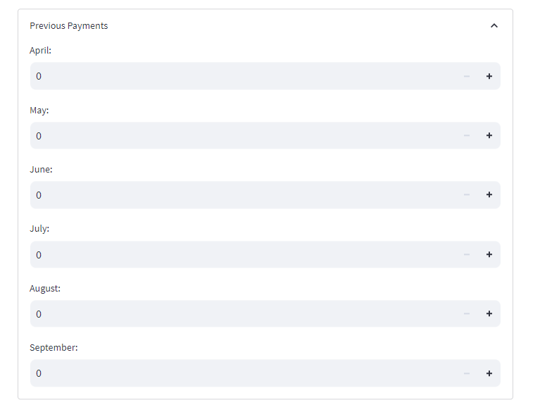

# Section 4: Prediction Result

After the user inputs all the necessary information, the app predicts whether the user will default on their credit card payment next month. The features include:

Prediction Text: The app displays a prediction text, which changes color based on the prediction result. If the prediction is "won't be a defaulter," the text is in green. If the prediction is "will be a defaulter," the text is in red.

Background Color: The background color of the prediction text changes dynamically based on the prediction result, enhancing the visual representation of the prediction.

